www.iojes.net | International Online Journal of Educational Sciences | 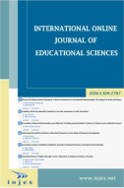
 | ISSN: 1309-2707
Please Write Here the Title of the Manuscript (Flush Left, Bold 14 pts, Palatino Linotype) Title of the article should be concise and should not exceed 15 words.
Research Article
Author Name¹ Author Name Author Name
¹………… University, Faculty of Education, Department of …., , ORCID: 0000-0002-7484-5685

To cite this article: Yaman, E. M. (2020). Evaluation of …………., International Online Journal of Educational Sciences, 12 (1), 1-18.
ARTICLE INFO |  | ABSTRACT
Article History:  Received: 01.01.2020  Available online: 03.03.2020 |  | Abstract should not be more than 250 words. Furthermore, 3 to 5 keywords should be provided. Abstract should not be more than 250 words. Furthermore, 3 to 5 keywords should be provided. Abstract should not be more than 250 words. Furthermore, 3 to 5 keywords should be provided. Abstract should not be more than 250 words. Furthermore, 3 to 5 keywords should be provided. Abstract should not be more than 250 words. Furthermore, 3 to 5 keywords should be provided. Abstract should not be more than 250 words. Furthermore, 3 to 5 keywords should be provided. Abstract should not be more than 250 words. Furthermore, 3 to 5 keywords should be provided. Abstract should not be more than 250 words. Furthermore, 3 to 5 keywords should be provided.  © 2020 IOJES. All rights reserved
Keywords:
3 to 5 keywords should be provided

Introduction
The problem of the study should be clearly indicated in the Introduction part. Introduction part should be followed by method, findings, discussion and conclusion. The problem of the study should be clearly indicated in the Introduction part. Introduction part should be followed by method, findings, discussion and conclusion. The problem of the study should be clearly indicated in the Introduction part. Introduction part should be followed by method, findings, discussion and conclusion.

Body text and all the headings will be Palatino Linotype, 10 pts, single space
First Level Heading
(Body text starts here)
Second Level Heading
(Body text starts here)
Third level heading. (Body text starts after the heading)
Fourth level heading. (Body text starts after the heading)
Fifth level heading. (Body text starts after the heading)

Sample tables and figures can be seen below. Each table and figure should be followed by a brief explanation. Please follow the APA 6 Style strictly in Table(s), Figure(s) and while writing the References. You can also check the style of articles published in the previous issue of IOJES.
Please use WS Word 2007 or later versions while uploading your articles.

Table 1. The learning area …………..
Scale | Subject matter | n | $$\overline{ X}$$ |  | sd
Organizational Image Perception  Psychological Well-being | Mathematics and Science | 93 | 3.65 | 0.62
 | Social Sciences | 209 | ..59 | 0.59
 | Mathematics and Science | 93 | 3,69 | 0.28
 | Social Sciences | 209 | 3.66 | 0.31

Table 2. Anova results of teachers’ opinions on the supervisory practices of school principals
Sub-heading | School type | n | X̅ | Sd | df | F | p
Instructional supervision | Kindergarten | 190 | 3.00 | .834 | 3  971 | .287 | .83
 | Primary school | 335 | 3.10 | .761
 | Secondary School | 244 | 3.05 | .910
 | High school | 206 | 3.01 | .711
Professional development | Kindergarten | 190 | 2.41 | .568 | 3  971 | .755 | .52
 | Primary school | 335 | 2.50 | .506
 | Secondary School | 244 | 2.30 | .578
 | High school | 206 | 2.39 | .556
Evaluation | Kindergarten | 190 | 3.40 | .615 | 3  971 | .149 | .93
 | Primary school | 335 | 3.50 | .614
 | Secondary School | 244 | 3.55 | .705
 | High school | 206 | 3.47 | .597

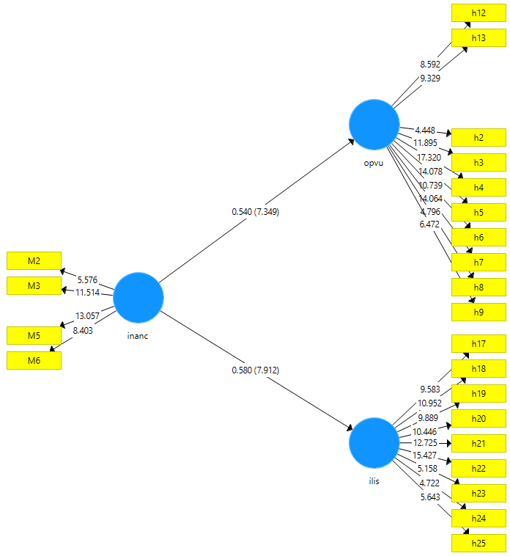
Figure 2. Measurement model

- Beliefs on the consistency of primary school teaching undergraduate curriculum(İ)

- Relations with students, professionals, managers, parents and society (REL)

- Teaching planning and implementation (TPI)

Please follow the APA 6 Style strictly in Table(s), Figure(s) and while writing the References. You can also check the style of articles published in the previous issue of IOJES.
Please use WS Word 2007 or later versions while uploading your articles.

Corresponding author’s address: Telephone: Fax: e-mail:

