www.iojes.net | International Online Journal of Educational Sciences | 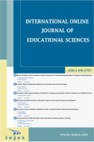
 | ISSN: 1309-2707
Please Write Here the Title of the Manuscript (Flush Left, Bold 14 pts, Palatino Linotype) Title of the article should be concise and should not exceed 15 words.
Research Article
Author Name¹ Author Name Author Name
¹………… University, Faculty of Education, Department of …., , ORCID: 0000-0002-7484-5685

To cite this article: Yaman, E. M. (2020). Evaluation of …………., International Online Journal of Educational Sciences, 12 (1), 1-18.
ARTICLE INFO |  | ABSTRACT
Article History:  Received: 01.01.2020  Available online: 03.03.2020 |  | Abstract should not be more than 250 words. Furthermore, 3 to 5 keywords should be provided. Abstract should not be more than 250 words. Furthermore, 3 to 5 keywords should be provided. Abstract should not be more than 250 words. Furthermore, 3 to 5 keywords should be provided. Abstract should not be more than 250 words. Furthermore, 3 to 5 keywords should be provided. Abstract should not be more than 250 words. Furthermore, 3 to 5 keywords should be provided. Abstract should not be more than 250 words. Furthermore, 3 to 5 keywords should be provided. Abstract should not be more than 250 words. Furthermore, 3 to 5 keywords should be provided. Abstract should not be more than 250 words. Furthermore, 3 to 5 keywords should be provided.  © 2022 IOJES. All rights reserved
Keywords:
3 to 5 keywords should be provided

Introduction
The problem of the study should be clearly indicated in the Introduction part. Introduction part should be followed by method, findings, discussion and conclusion. The problem of the study should be clearly indicated in the Introduction part. Introduction part should be followed by method, findings, discussion and conclusion. The problem of the study should be clearly indicated in the Introduction part. Introduction part should be followed by method, findings, discussion and conclusion.

Body text and all the headings will be Palatino Linotype, 10 pts, single space
First Level Heading

(Body text starts here)
Second Level Heading
(Body text starts here)
Third level heading. (Body text starts after the heading)
Fourth level heading. (Body text starts after the heading)
Fifth level heading. (Body text starts after the heading)

Methodology
Please give information about the method (sampling, research method, data collection if applicable, etc). Also Ethics Committee Approval information (the title of the ethics committee, date, and number) must be stated clearly in the method section as well as on the last page of the manuscript.

Sample tables and figures can be seen below. Each table and figure should be followed by a brief explanation. Please follow the APA 6 Style strictly in Table(s), Figure(s) and while writing the References. You can also check the style of articles published in the previous issue of IOJES.
Please use WS Word 2007 or later versions while uploading your articles.

Table 1. The learning area …………..
Scale | Subject matter | n | $$\overline{ X}$$ |  | sd
Organizational Image Perception  Psychological Well-being | Mathematics and Science | 93 | 3.65 | 0.62
 | Social Sciences | 209 | ..59 | 0.59
 | Mathematics and Science | 93 | 3,69 | 0.28
 | Social Sciences | 209 | 3.66 | 0.31

Table 2. Anova results of teachers’ opinions on the supervisory practices of school principals
Sub-heading | School type | n | X̅ | Sd | df | F | p
Instructional supervision | Kindergarten | 190 | 3.00 | .834 | 3  971 | .287 | .83
 | Primary school | 335 | 3.10 | .761
 | Secondary School | 244 | 3.05 | .910
 | High school | 206 | 3.01 | .711
Professional development | Kindergarten | 190 | 2.41 | .568 | 3  971 | .755 | .52
 | Primary school | 335 | 2.50 | .506
 | Secondary School | 244 | 2.30 | .578
 | High school | 206 | 2.39 | .556
Evaluation | Kindergarten | 190 | 3.40 | .615 | 3  971 | .149 | .93
 | Primary school | 335 | 3.50 | .614
 | Secondary School | 244 | 3.55 | .705
 | High school | 206 | 3.47 | .597

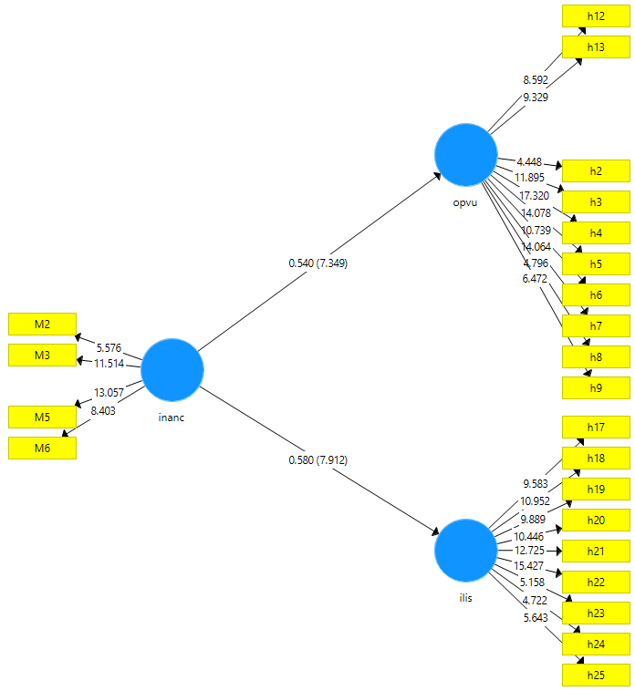
Figure 2. Measurement model

- Beliefs on the consistency of primary school teaching undergraduate curriculum(İ)

- Relations with students, professionals, managers, parents and society (REL)

- Teaching planning and implementation (TPI)

Please follow the APA 6 Style strictly in Table(s), Figure(s) and while writing the References. You can also check the style of articles published in the previous issue of IOJES.
Please use WS Word 2007 or later versions while uploading your articles.

Ethics Committee Approval:
The authors have to provide and submit an “Ethics Committee Approval” document while submitting their manuscript to IOJES journal. This document should be obtained from the related Ethical Committees of the universities. It is a requirement by ULAKBIM TR DİZİN for the journals waiting for possible inclusion in the TR DİZİN. All qualitative or quantitative studies which included data collection from participants by questionnaire, interview, focus group study, observation, and experiment must have the Ethics Committee Approval document. Ethics Committee Approval is not required for review articles. Ethics Committee Approval information (the title of the ethics committee, date, and number) must be stated clearly in the method section as well as on the last page of the manuscript.

Corresponding author’s address: Telephone: Fax: e-mail:

